Latent Growth Models with Raw Scale Scores

KN

July 22, 2022

Table of Contents

Methods 1

Results 2

Latent Growth Model - Full Sample 2

LGM Stratified by Group 3

SH Perpetration predicted by HHE 4

Multigroup Analysis 4

Sex 4

Race 5

School Belonging 5

Full Conditional Model 6

Gender 6

Race 7

School Belonging 8

Additional Plots for Paper 9

# Methods

Raw scale scores were calculated as the sum of the dichotomous items for Sexual Harassment. A student must have answered 3 or more items in the scale to receive a scale score. Descriptive statistics and correlations between the scale scores at each wave are in Table 1.

The latent growth model was specified by loading the scale score at each wave onto an intercept and slope factor. We also tested the utility of a quadratic factor. The models were run in Mplus using a robust maximum likelihood estimator with cluster robust standard errors accounting for the nesting structure of students within schools. Missing data was handled using full information maximum likelihood.

Multigroup analyses by gender, race, and school belonging were then run on the latent growth models for each outcome to examine differences in the parameter estimates. Prior to the multigroup analysis, the latent growth model for each outcome was fit separately to each group. Then, for a given variable (e.g., gender), the latent growth model was fit with the parameter estimate equality between groups tested using a Wald test.

Lastly, Wave 1 variables were added to the model as intercept and slope predictors. When the multigroup analysis indicated groups had different intercepts and slopes, the model with predictors was fit separately to each group.

# Results

**Table 1.**

*Correlations and Descriptive Statistics*

| var | 1 | 2 | 3 | 4 | 5 | 6 | 7 | 8 | 9 | 10 | 11 | 12 | 13 | 14 |
| --- | --- | --- | --- | --- | --- | --- | --- | --- | --- | --- | --- | --- | --- | --- |
| 1. Sexual Harassment W1 |  |  |  |  |  |  |  |  |  |  |  |  |  |  |
| 2. Sexual Harassment W2 | 0.36* |  |  |  |  |  |  |  |  |  |  |  |  |  |
| 3. Sexual Harassment W3 | 0.29* | 0.41* |  |  |  |  |  |  |  |  |  |  |  |  |
| 4. Sexual Harassment W4 | 0.25* | 0.30* | 0.40* |  |  |  |  |  |  |  |  |  |  |  |
| 5. Family Conflict | 0.16* | 0.10* | 0.13* | 0.09* |  |  |  |  |  |  |  |  |  |  |
| 6. Abuse | 0.23* | 0.18* | 0.09* | 0.06 | 0.32* |  |  |  |  |  |  |  |  |  |
| 7. Sibling Aggression | 0.11* | 0.05 | 0.05 | 0.04 | 0.29* | 0.17* |  |  |  |  |  |  |  |  |
| 8. SH Victim | 0.34* | 0.21* | 0.17* | 0.21* | 0.27* | 0.20* | 0.13* |  |  |  |  |  |  |  |
| 9. Female | -0.05* | -0.11* | -0.08* | -0.07* | 0.03 | -0.06* | 0.00 | 0.04 |  |  |  |  |  |  |
| 10. Black | 0.05 | -0.01 | 0.04 | 0.07* | 0.06* | 0.08* | -0.04 | 0.07* | 0.02 |  |  |  |  |  |
| 11. White | -0.05 | -0.05 | -0.07* | -0.03 | 0.05 | -0.05 | -0.01 | 0.02 | 0.00 | -0.31* |  |  |  |  |
| 12. OtherR | 0.02 | 0.04 | 0.04 | 0.07* | 0.04 | 0.01 | 0.02 | 0.05 | -0.01 | -0.25* | -0.19* |  |  |  |
| 13. High Belong | -0.13* | -0.21* | -0.18* | -0.16* | -0.13* | -0.08* | -0.05* | -0.17* | 0.08* | -0.07* | 0.02 | -0.04 |  |  |
| 14. GRADES W1 | -0.01 | -0.05 | -0.07* | -0.04 | -0.02 | -0.01 | -0.02 | 0.02 | 0.06* | -0.03 | 0.09* | 0.07* | 0.17* |  |
| Descriptives |  |  |  |  |  |  |  |  |  |  |  |  |  |  |
| missing_rate | 0.01 | 0.08 | 0.25 | 0.36 | 0.08 | 0.09 | 0.05 | 0.01 | 0.00 | 0.00 | 0.00 | 0.00 | 0.00 | 0.13 |
| mean | 0.23 | 0.27 | 0.35 | 0.37 | 0.78 | 0.39 | 0.34 | 0.28 | 0.49 | 0.29 | 0.19 | 0.13 | 0.60 | 4.48 |
| sd | 0.72 | 0.73 | 0.86 | 0.92 | 0.88 | 0.71 | 0.91 | 0.45 | 0.50 | 0.46 | 0.39 | 0.33 | 0.49 | 1.43 |
| skew | 4.26 | 3.52 | 3.19 | 3.40 | 1.36 | 1.80 | 3.54 | 0.96 | 0.05 | 0.90 | 1.58 | 2.22 | -0.40 | -1.22 |
| kurtosis | 21.42 | 14.45 | 11.73 | 13.38 | 1.58 | 2.41 | 13.02 | -1.09 | -2.00 | -1.18 | 0.49 | 2.94 | -1.85 | 0.97 |

*Note.* SH = Sexual Harassment. \**p* < .05

## Latent Growth Model - Full Sample

**Model Fit**

| model | ntotal | npar | x2 | df | p | cfi | rmsea | rmsea.ci | srmr | AIC | BIC | aBIC |
| --- | --- | --- | --- | --- | --- | --- | --- | --- | --- | --- | --- | --- |
| sh.lgm.out | 1,563.00 | 9.00 | 4.17 | 5.00 | 0.53 | 1.00 | 0.00 | [0.00, 0.03] | 0.02 | 11,611.35 | 11,659.54 | 11,630.95 |
| sh.quad.lgm.out | 1,563.00 | 13.00 | 0.40 | 1.00 | 0.53 | 1.00 | 0.00 | [0.00, 0.06] | 0.00 | 11,607.80 | 11,677.41 | 11,636.11 |
| difference |  |  | 3.41 | 4.00 | 0.49 | 0.00 | 0.00 |  | 0.02 |  |  |  |

**Unstandardized Parameter Estimates**

| outcome | Means_I | Means_Q | Means_S | Variances_I | Variances_Q | Variances_S | Q.WITH_I | Q.WITH_S | S.WITH_I |
| --- | --- | --- | --- | --- | --- | --- | --- | --- | --- |
| Sexual Harassment | 0.23 (0.03)** |  | 0.07 (0.02)** | 0.21 (0.04)** |  | 0.05 (0.02)* |  |  | -0.01 (0.02) |
| Sexual Harassment - Quadratic | 0.22 (0.03)** | -0.02 (0.02) | 0.11 (0.04)** | 0.18 (0.08)* | 0.03 (0.04) | 0.16 (0.29) | -0.02 (0.05) | -0.06 (0.10) | 0.04 (0.14) |

*Note.* Cluster robust standard errors are in the parentheses (). \**p* < .05

## LGM Stratified by Group

**Model Fit**

| outcome | ntotal | npar | chisq | df | pvalue | cfi | rmsea | rmsea.ci | srmr |
| --- | --- | --- | --- | --- | --- | --- | --- | --- | --- |
| Black | 459.00 | 9.00 | 5.01 | 5.00 | 0.42 | 1.00 | 0.00 | [0.00, 0.06] | 0.04 |
| Girls | 761.00 | 9.00 | 2.72 | 5.00 | 0.74 | 1.00 | 0.00 | [0.00, 0.04] | 0.04 |
| School Belonging - High | 932.00 | 7.00 | 12.47 | 7.00 | 0.09 | 0.92 | 0.03 | [0.00, 0.06] | 0.06 |
| Hispanic | 605.00 | 9.00 | 5.13 | 5.00 | 0.40 | 1.00 | 0.01 | [0.00, 0.06] | 0.04 |
| Boys | 796.00 | 9.00 | 3.78 | 5.00 | 0.58 | 1.00 | 0.00 | [0.00, 0.04] | 0.03 |
| School Belonging - Moderate | 629.00 | 9.00 | 7.40 | 5.00 | 0.19 | 0.98 | 0.03 | [0.00, 0.07] | 0.03 |
| Other Race | 201.00 | 7.00 | 11.28 | 7.00 | 0.13 | 0.86 | 0.06 | [0.00, 0.11] | 0.11 |
| White | 298.00 | 9.00 | 4.11 | 5.00 | 0.53 | 1.00 | 0.00 | [0.00, 0.07] | 0.06 |

**Unstandardized Parameter Estimates**

| outcome | Means_I | Means_S | Variances_I | Variances_S | S.WITH_I |
| --- | --- | --- | --- | --- | --- |
| Black | 0.25 (0.04)** | 0.09 (0.04)* | 0.21 (0.06)** | 0.05 (0.05) | -0.03 (0.04) |
| Boys | 0.28 (0.04)** | 0.08 (0.03)** | 0.24 (0.06)** | 0.05 (0.04) | -0.01 (0.04) |
| Girls | 0.17 (0.02)** | 0.07 (0.02)** | 0.17 (0.05)** | 0.05 (0.02)* | -0.02 (0.03) |
| Hispanic | 0.23 (0.05)** | 0.04 (0.03) | 0.21 (0.09)* | 0.06 (0.03) | -0.03 (0.04) |
| Other Race | 0.27 (0.04)** | 0.12 (0.03)** | 0.23 (0.08)** | 0.00 (0.00) |  |
| School Belonging - High | 0.14 (0.02)** | 0.06 (0.01)** | 0.10 (0.02)** | 0.00 (0.00) |  |
| School Belonging - Moderate | 0.37 (0.04)** | 0.10 (0.03)** | 0.32 (0.08)** | 0.14 (0.05)** | -0.03 (0.05) |
| White | 0.16 (0.03)** | 0.06 (0.02)** | 0.26 (0.12)* | 0.05 (0.04) | -0.02 (0.06) |

## SH Perpetration predicted by HHE

**Table 2**

*Unstandardized Estimates from Latent Growth Model of Sexual Harassment Perpetration (n = 1563)*

| Predictor | Intercept | Slope |
| --- | --- | --- |
| Intercept term | 0.03 (0.02) | 0.09 (0.01)** |
| Family Conflict | 0.01 (0.03) | 0.02 (0.02) |
| Abuse | 0.17 (0.05)** | -0.06 (0.02)** |
| Sibling Aggression | 0.02 (0.02) | 0.00 (0.01) |
| SH Victim | 0.42 (0.05)** | -0.04 (0.04) |
| *R*2 | 0.29 (0.03) | 0.04 (0.03) |

*Note.* Parentheses contain cluster robust standard errors. SH = Sexual Harassment. Model fit was χ2 (13) = 23.96, *p* = 0.03; *CFI* = 0.97; *RMSEA* = 0.02 [0.01, 0.04]; *SRMR* = 0.02. \**p* < .05, \*\**p* < .01

*Standardized Estimates from Latent Growth Model of Sexual Harassment Perpetration (n = 1563)*

| Predictor | Intercept | Slope |
| --- | --- | --- |
| Intercept term | 0.07 (0.04) | 0.41 (0.10)** |
| Family Conflict | 0.01 (0.05) | 0.06 (0.09) |
| Abuse | 0.26 (0.06)** | -0.19 (0.04)** |
| Sibling Aggression | 0.04 (0.05) | -0.01 (0.04) |
| SH Victim | 0.41 (0.04)** | -0.07 (0.08) |
| *R*2 | 0.29 (0.03) | 0.04 (0.03) |

*Note.* Parentheses contain cluster robust standard errors. SH = Sexual Harassment. Model fit was χ2 (13) = 23.96, *p* = 0.03; *CFI* = 0.97; *RMSEA* = 0.02 [0.01, 0.04]; *SRMR* = 0.02. \**p* < .05, \*\**p* < .01

## Multigroup Analysis

### Sex

See Mplus files for n’s by group.

**Table 3**

*Multigroup Analysis of Sexual Harassment Perpetration on Hostile Home Environment by Sex*

| Parameter | Girls  *n* = 761 | Boys  *n* = 797 | *Wald* χ2  *df = 1* | *p* |
| --- | --- | --- | --- | --- |
| Intercept on |  |  |  |  |
| Intercept term | -0.02 (0.02) | 0.08 (0.03)* | 4.49 | 0.03 |
| Family Conflict | 0.03 (0.04) | 0.00 (0.04) | 0.21 | 0.64 |
| Abuse | 0.19 (0.05)** | 0.14 (0.07) | 0.36 | 0.55 |
| Sibling Aggression | 0.00 (0.04) | 0.03 (0.03) | 0.45 | 0.50 |
| Slope on |  |  |  |  |
| Intercept term | 0.08 (0.02)** | 0.11 (0.03)** | 0.37 | 0.54 |
| Family Conflict | 0.01 (0.02) | 0.01 (0.04) | 0.00 | 0.99 |
| Abuse | -0.06 (0.04) | -0.06 (0.02)** | 0.02 | 0.89 |
| Sibling Aggression | 0.00 (0.02) | 0.00 (0.02) | 0.01 | 0.91 |

*Note.* Estimates are unstandardized. Parentheses contain cluster robust standard errors. Model fit was χ2 (26) = 26.89, *p* = 0.42; *CFI* = 1.00; *RMSEA* = 0.01 [0.00, 0.03]; *SRMR* = 0.03. Omnibus Wald χ2 (8) = 55.81, *p* = 0.\**p* < .05, \*\**p* < .01

*Standardized Estimates from Multigroup Analysis of Sexual Harassment Perpetration on Hostile Home Environment by Sex*

| Parameter | Girls  *n* = 761 | Boys  *n* = 797 | *Wald* χ2  *df = 1* | *p* |
| --- | --- | --- | --- | --- |
| Intercept on |  |  |  |  |
| Intercept term | -0.04 (0.05) | 0.16 (0.06)* | 4.49 | 0.03 |
| Family Conflict | 0.06 (0.08) | 0.00 (0.08) | 0.21 | 0.64 |
| Abuse | 0.30 (0.06)** | 0.20 (0.09)* | 0.36 | 0.55 |
| Sibling Aggression | 0.01 (0.08) | 0.06 (0.05) | 0.45 | 0.50 |
| Slope on |  |  |  |  |
| Intercept term | 0.37 (0.09)** | 0.44 (0.17)* | 0.37 | 0.54 |
| Family Conflict | 0.05 (0.09) | 0.05 (0.14) | 0.00 | 0.99 |
| Abuse | -0.20 (0.10) | -0.18 (0.03)** | 0.02 | 0.89 |
| Sibling Aggression | 0.01 (0.08) | 0.00 (0.07) | 0.01 | 0.91 |

*Note.* Parentheses contain cluster robust standard errors. Model fit was χ2 (26) = 26.89, *p* = 0.42; *CFI* = 1.00; *RMSEA* [90% CI] = 0.01 [0.00, 0.03]; *SRMR* = 0.03. Omnibus Wald χ2 (8) = 55.81, *p* < .01.\**p* < .05, \*\**p* < .01

### 

### Race

See Mplus files for n’s by group.

**Table 4**

*Multigroup Analysis of Sexual Harassment Perpetration on Hostile Home Environment by Race/Ethnicity*

| Parameter | Black  *n =* 460 | White  *n =* 298 | Hispanic  *n =* 605 | *Wald* χ2  *df = 1* | | *p* |
| --- | --- | --- | --- | --- | --- | --- |
| Intercept on |  |  |  | |  |  |
| Intercept term | 0.01 (0.04) | 0.03 (0.04) | 0.03 (0.01)* | | 0.44 | 0.80 |
| Family Conflict | 0.04 (0.03) | 0.01 (0.04) | 0.00 (0.04) | | 0.99 | 0.61 |
| Abuse | 0.07 (0.05) | 0.17 (0.10) | 0.25 (0.06)** | | 3.16 | 0.21 |
| Sibling Aggression | 0.06 (0.04) | 0.00 (0.08) | 0.00 (0.03) | | 2.11 | 0.35 |
| Slope on |  |  |  | |  |  |
| Intercept term | 0.11 (0.03)** | 0.05 (0.03)* | 0.08 (0.02)** | | 2.76 | 0.25 |
| Family Conflict | 0.02 (0.04) | 0.02 (0.03) | 0.02 (0.02) | | 0.00 | 1.00 |
| Abuse | -0.02 (0.04) | -0.14 (0.05)** | -0.10 (0.03)** | | 3.16 | 0.21 |
| Sibling Aggression | -0.01 (0.02) | 0.01 (0.03) | 0.00 (0.02) | | 0.44 | 0.80 |

*Note.* Estimates are unstandardized. Parentheses contain cluster robust standard errors. Model fit was χ2 (39) = 48.05, *p* = 0.15; *CFI* = 0.98; *RMSEA* = 0.02 [0.00, 0.04]; *SRMR* = 0.03. Omnibus Wald χ2 (16) = 10759.10, *p* < .01.\**p* < .05, \*\**p* < .01

*Standardized Estimates from Multigroup Analysis of Sexual Harassment Perpetration on Hostile Home Environment by Race/Ethnicity*

| Parameter | Black  *n =* 460 | White  *n =* 298 | Hispanic  *n =* 605 | *Wald* χ2  *df = 1* | *p* |
| --- | --- | --- | --- | --- | --- |
| Intercept on |  |  |  |  |  |
| Intercept term | 0.03 (0.07) | 0.05 (0.08) | 0.07 (0.04)* | 0.44 | 0.80 |
| Family Conflict | 0.09 (0.07) | 0.02 (0.07) | 0.00 (0.07) | 0.99 | 0.61 |
| Abuse | 0.12 (0.08) | 0.21 (0.12) | 0.36 (0.05)** | 3.16 | 0.21 |
| Sibling Aggression | 0.10 (0.05) | 0.00 (0.14) | -0.01 (0.07) | 2.11 | 0.35 |
| Slope on |  |  |  |  |  |
| Intercept term | 0.45 (0.16)** | 0.22 (0.16) | 0.33 (0.09)** | 2.76 | 0.25 |
| Family Conflict | 0.08 (0.14) | 0.08 (0.12) | 0.07 (0.08) | 0.00 | 1.00 |
| Abuse | -0.07 (0.10) | -0.40 (0.15)** | -0.28 (0.09)** | 3.16 | 0.21 |
| Sibling Aggression | -0.04 (0.08) | 0.05 (0.10) | 0.02 (0.07) | 0.44 | 0.80 |

*Note.* Parentheses contain cluster robust standard errors. Model fit was χ2 (39) = 48.05, *p* = 0.15; *CFI* = 0.98; *RMSEA* = 0.02 [0.00, 0.04]; *SRMR* = 0.03. Omnibus Wald χ2 (16) = 10759.10, *p* < .01. \*\**p* < .05, \*\**p* < .01

### 

### School Belonging

See Mplus files for n’s by group.

**Table 5**

*Multigroup Analysis of Sexual Harassment Perpetration on Hostile Home Environment by School Belonging*

| Parameter | Higha  *n =* 932 | Moderate  *n =* 629 | *Wald* χ2  *df = 1* | *p* |
| --- | --- | --- | --- | --- |
| Intercept on |  |  |  |  |
| Intercept term | 0.04 (0.02)* | 0.04 (0.04) | 0.00 | 0.98 |
| Family Conflict | -0.01 (0.03) | 0.02 (0.04) | 0.53 | 0.47 |
| Abuse | 0.10 (0.06) | 0.23 (0.06)** | 2.40 | 0.12 |
| Sibling Aggression | 0.01 (0.02) | 0.03 (0.03) | 0.85 | 0.36 |
| Slope on |  |  |  |  |
| Intercept term | 0.07 (0.02)** | 0.15 (0.03)** | 4.02 | 0.04 |
| Family Conflict | 0.01 (0.03) | 0.00 (0.02) | 0.06 | 0.80 |
| Abuse | -0.03 (0.03) | -0.10 (0.04)** | 1.39 | 0.24 |
| Sibling Aggression | 0.00 (0.01) | 0.00 (0.04) | 0.00 | 0.96 |

*Note.* Estimates based on standardized intercept and slope and unstandardized predictors. Parentheses contain cluster robust standard errors. aSlope variance was constrained to 0. Model fit was χ2 (28) = 53.50, *p* = 0.00; *CFI* = 0.93; *RMSEA* = 0.03 [0.02, 0.05]; *SRMR* = 0.04. Omnibus Wald χ2 (8) = 114.23, *p* < .01. \*\**p* < .05, \**p* < .01

*Standardized Estimates from Multigroup Analysis of Sexual Harassment Perpetration on Hostile Home Environment by School Belonging*

| Parameter | Higha  *n =* 932 | Moderate  *n =* 629 | *Wald* χ2  *df = 1* | *p* |
| --- | --- | --- | --- | --- |
| Intercept on |  |  |  |  |
| Intercept term | 0.13 (0.06)* | 0.07 (0.07) | 0.00 | 0.98 |
| Family Conflict | -0.03 (0.08) | 0.04 (0.06) | 0.53 | 0.47 |
| Abuse | 0.21 (0.12) | 0.30 (0.08)** | 2.40 | 0.12 |
| Sibling Aggression | 0.02 (0.06) | 0.05 (0.04) | 0.85 | 0.36 |
| Slope on |  |  |  |  |
| Intercept term | 2.27 (1.27) | 0.39 (0.07)** | 4.02 | 0.04 |
| Family Conflict | 0.38 (0.75) | 0.01 (0.06) | 0.06 | 0.80 |
| Abuse | -0.72 (0.63) | -0.19 (0.06)** | 1.39 | 0.24 |
| Sibling Aggression | 0.02 (0.38) | 0.00 (0.10) | 0.00 | 0.96 |

*Note.* Parentheses contain cluster robust standard errors. aSlope variance was constrained to 0. Model fit was χ2 (28) = 53.50, *p* = 0.00; *CFI* = 0.93; *RMSEA* = 0.03 [0.02, 0.05]; *SRMR* = 0.04. Omnibus Wald χ2 (8) = 114.23, *p* = 0.\**p* < .05, \*\**p* < .01

## Full Conditional Model

### Gender

**Table 6**

*Unstandardized Estimates from Latent Growth Model of Sexual Harassment Perpetration Stratified by Sex*

|  | Girls | | Boys | |
| --- | --- | --- | --- | --- |
| Intercept | Slope | Intercept | Slope |
| Intercept term | 0.03 (0.07) | 0.05 (0.10) | 0.12 (0.05)* | 0.15 (0.06)** |
| Family Conflict (FC) | -0.01 (0.09) | 0.21 (0.14) | 0.07 (0.12) | 0.06 (0.08) |
| Abuse | 0.59 (0.26)* | -0.50 (0.20)* | 0.05 (0.21) | -0.02 (0.13) |
| Sibling Aggression (SA) | 0.19 (0.05)** | 0.06 (0.10) | 0.01 (0.04) | -0.15 (0.09) |
| Sexual Harassment Victim | 0.33 (0.06)** | -0.05 (0.04) | 0.47 (0.05)** | -0.06 (0.04) |
| Black | -0.11 (0.04)* | 0.10 (0.05)* | -0.01 (0.04) | 0.01 (0.06) |
| White | -0.11 (0.05)* | 0.01 (0.04) | -0.09 (0.04)* | 0.03 (0.04) |
| Other Race | -0.06 (0.05) | 0.13 (0.07) | -0.04 (0.07) | 0.07 (0.08) |
| High School Belonging (HSB) | -0.05 (0.05) | -0.10 (0.06) | 0.02 (0.08) | -0.05 (0.05) |
| Academic Grades (AG) | 0.01 (0.02) | 0.01 (0.02) | -0.01 (0.02) | 0.00 (0.01) |
| FC x HSB | -0.01 (0.07) | 0.01 (0.06) | -0.09 (0.07) | -0.02 (0.04) |
| Abuse x HSB | -0.10 (0.11) | 0.07 (0.06) | -0.21 (0.08)** | 0.05 (0.05) |
| SA x HSB | -0.01 (0.04) | -0.02 (0.04) | -0.04 (0.06) | 0.05 (0.07) |
| FC x AG | 0.01 (0.02) | -0.04 (0.03) | 0.00 (0.03) | -0.01 (0.01) |
| Abuse x AG | -0.08 (0.05) | 0.08 (0.04)* | 0.05 (0.06) | -0.01 (0.03) |
| SA x AG | -0.04 (0.01)** | -0.01 (0.02) | 0.01 (0.02) | 0.03 (0.01) |
| *R*2 | 0.40 (0.09) | 0.25 (0.08) | 0.36 (0.05) | 0.09 (0.04) |
| χ2 (35) | 42.88 | | 39.52 | |
| *n* | 761 | | 797 | |
| *CFI* | 0.98 | | 0.98 | |
| *RMSEA* | 0.02 [0.00, 0.03] | | 0.01 [0.00, 0.03] | |
| *SRMR* | 0.02 | | 0.02 | |

*Note.* Parentheses contain cluster robust standard errors. \**p* < .05, \*\**p* < .01

*Standardized Estimates from Latent Growth Model of Sexual Harassment Perpetration Stratified by Sex*

|  | Girls | | Boys | |
| --- | --- | --- | --- | --- |
| Intercept | Slope | Intercept | Slope |
| Intercept term | 0.07 (0.18) | 0.22 (0.43) | 0.24 (0.10)* | 0.61 (0.27)* |
| Family Conflict (FC) | -0.02 (0.20) | 0.81 (0.47) | 0.13 (0.20) | 0.20 (0.32) |
| Abuse | 0.96 (0.35)** | -1.51 (0.40)** | 0.07 (0.31) | -0.05 (0.40) |
| Sibling Aggression (SA) | 0.43 (0.15)** | 0.24 (0.44) | 0.03 (0.08) | -0.53 (0.27)* |
| Sexual Harassment Victim | 0.36 (0.06)** | -0.09 (0.09) | 0.42 (0.07)** | -0.11 (0.08) |
| Black | -0.12 (0.04)** | 0.19 (0.10) | -0.01 (0.04) | 0.01 (0.11) |
| White | -0.10 (0.05) | 0.03 (0.07) | -0.07 (0.03)* | 0.04 (0.07) |
| Other Race | -0.05 (0.04) | 0.19 (0.10) | -0.03 (0.05) | 0.10 (0.11) |
| High School Belonging (HSB) | -0.06 (0.05) | -0.22 (0.10)* | 0.02 (0.08) | -0.11 (0.09) |
| Academic Grades (AG) | 0.03 (0.06) | 0.08 (0.14) | -0.02 (0.05) | -0.03 (0.07) |
| FC x HSB | -0.02 (0.12) | 0.04 (0.17) | -0.14 (0.09) | -0.07 (0.14) |
| Abuse x HSB | -0.11 (0.14) | 0.14 (0.12) | -0.25 (0.09)** | 0.12 (0.14) |
| SA x HSB | -0.02 (0.07) | -0.06 (0.14) | -0.05 (0.09) | 0.15 (0.18) |
| FC x AG | 0.10 (0.17) | -0.81 (0.49) | -0.03 (0.22) | -0.13 (0.27) |
| Abuse x AG | -0.60 (0.31) | 1.21 (0.36)** | 0.33 (0.41) | -0.20 (0.38) |
| SA x AG | -0.45 (0.14)** | -0.16 (0.33) | 0.08 (0.16) | 0.45 (0.26) |
| *R*2 | 0.40 (0.09) | 0.25 (0.08) | 0.36 (0.05) | 0.09 (0.04) |
| χ2 (35) | 42.88 | | 39.52 | |
| *n* | 761 | | 797 | |
| *CFI* | .98 | | .98 | |
| *RMSEA* | 0.02 [0.00, 0.03] | | 0.01 [0.00, 0.03] | |
| *SRMR* | 0.02 | | 0.02 | |

*Note.* Parentheses contain cluster robust standard errors. \**p* < .05, \**p* < .01

### 

### Race

**Table 7**

*Unstandardized Estimates from Latent Growth Model of Sexual Harassment Perpetration Stratified by Race*

|  | Black | | Whitea | | Hispanic | |
| --- | --- | --- | --- | --- | --- | --- |
| Intercept | Slope | Intercept | Slope | Intercept | Slope |
| Intercept term | 0.10 (0.10) | 0.00 (0.09) | 0.15 (0.11) | 0.18 (0.13) | 0.18 (0.06)** | 0.17 (0.08)* |
| Family Conflict (FC) | 0.13 (0.07) | 0.17 (0.08)* | -0.05 (0.06) | 0.05 (0.03) | -0.04 (0.20) | 0.07 (0.13) |
| Abuse | -0.06 (0.15) | -0.16 (0.10) | 0.07 (0.17) | -0.20 (0.10)* | 0.38 (0.19)* | -0.32 (0.09)** |
| Sibling Aggression (SA) | -0.02 (0.09) | 0.22 (0.09)* | 0.12 (0.05)* | 0.02 (0.03) | 0.02 (0.06) | -0.10 (0.06) |
| Sexual Harassment Victim | 0.40 (0.06)** | -0.05 (0.04) | 0.24 (0.09)** | 0.10 (0.06) | 0.50 (0.07)** | -0.11 (0.03)** |
| Girls | -0.16 (0.05)** | 0.05 (0.04) | -0.10 (0.07) | -0.04 (0.04) | -0.07 (0.05) | -0.05 (0.03) |
| High School Belonging (HSB) | 0.00 (0.09) | -0.05 (0.05) | -0.20 (0.06)** | 0.02 (0.05) | 0.01 (0.06) | -0.07 (0.04) |
| Academic Grades (AG) | 0.00 (0.03) | 0.02 (0.02) | 0.01 (0.03) | -0.03 (0.04) | -0.03 (0.01)* | 0.00 (0.01) |
| FC x HSB | -0.12 (0.07) | 0.00 (0.05) | 0.12 (0.06) | -0.03 (0.04) | -0.06 (0.14) | -0.04 (0.09) |
| Abuse x HSB | -0.06 (0.13) | 0.03 (0.07) | 0.14 (0.21) | 0.10 (0.12) | -0.27 (0.15) | 0.08 (0.10) |
| SA x HSB | 0.03 (0.07) | 0.03 (0.06) | -0.27 (0.09)** | -0.01 (0.09) | 0.01 (0.05) | 0.04 (0.06) |
| FC x AG | 0.00 (0.02) | -0.03 (0.02)* |  |  | 0.02 (0.03) | 0.00 (0.01) |
| Abuse x AG | 0.04 (0.03) | 0.03 (0.02) |  |  | 0.00 (0.04) | 0.04 (0.02)* |
| SA x AG | 0.01 (0.03) | -0.06 (0.02)** |  |  | -0.01 (0.01) | 0.02 (0.01) |
| *R*2 | 0.36 (0.08) | 0.20 (0.14) | 0.19 (0.05) | 0.22 (0.12) | 0.51 (0.09) | 0.20 (0.14) |
| χ2 | 43.14; *df* = 31 | | 36.39; *df* = 25 | | 47.78*; *df* = 31 | |
| *n* | 460 | | 298 | | 605 | |
| *CFI* | 0.94 | | 0.94 | | 0.96 | |
| *RMSEA* | 0.03 [0.00, 0.05] | | 0.04 [0.00, 0.06] | | 0.03 [0.01, 0.05] | |
| *SRMR* | 0.02 | | 0.03 | | 0.02 | |

*Note.* Parentheses contain cluster robust standard errors. aInteractions of home hostility and academic grades yielded poor model fit and were removed. \**p* < .05, \**p* < .01

*Standardized Estimates from Latent Growth Model of Sexual Harassment Perpetration Stratified by Race*

|  | Black | | Whitea | | Hispanic | |
| --- | --- | --- | --- | --- | --- | --- |
| Intercept | Slope | Intercept | Slope | Intercept | Slope |
| Intercept term | 0.22 (0.24) | 0.01 (0.35) | 0.29 (0.25) | 0.80 (0.54) | 0.40 (0.16)* | 0.67 (0.26)* |
| Family Conflict (FC) | 0.26 (0.13)* | 0.60 (0.26)* | -0.09 (0.10) | 0.18 (0.16) | -0.07 (0.34) | 0.23 (0.46) |
| Abuse | -0.11 (0.26) | -0.48 (0.24)* | 0.09 (0.20) | -0.58 (0.20)** | 0.56 (0.31) | -0.84 (0.35)* |
| Sibling Aggression (SA) | -0.03 (0.16) | 0.69 (0.34)* | 0.20 (0.10)* | 0.07 (0.09) | 0.04 (0.12) | -0.38 (0.26) |
| Sexual Harassment Victim | 0.40 (0.07)** | -0.10 (0.06) | 0.22 (0.08)** | 0.21 (0.10)* | 0.44 (0.06)** | -0.17 (0.06)** |
| Girls | -0.18 (0.07)** | 0.09 (0.09) | -0.10 (0.07) | -0.10 (0.10) | -0.07 (0.05) | -0.10 (0.06) |
| High School Belonging (HSB) | 0.00 (0.10) | -0.09 (0.08) | -0.19 (0.07)** | 0.05 (0.11) | 0.01 (0.06) | -0.13 (0.08) |
| Academic Grades (AG) | 0.00 (0.09) | 0.13 (0.11) | 0.03 (0.06) | -0.15 (0.19) | -0.09 (0.04)* | -0.02 (0.07) |
| FC x HSB | -0.20 (0.11) | -0.01 (0.15) | 0.18 (0.09)* | -0.11 (0.15) | -0.08 (0.18) | -0.10 (0.23) |
| Abuse x HSB | -0.08 (0.18) | 0.08 (0.17) | 0.15 (0.24) | 0.23 (0.23) | -0.28 (0.16) | 0.15 (0.22) |
| SA x HSB | 0.04 (0.09) | 0.07 (0.14) | -0.29 (0.10)** | -0.03 (0.21) | 0.01 (0.09) | 0.15 (0.19) |
| FC x AG | -0.04 (0.16) | -0.55 (0.24)* |  |  | 0.12 (0.19) | -0.06 (0.22) |
| Abuse x AG | 0.30 (0.23) | 0.38 (0.25) |  |  | -0.01 (0.25) | 0.45 (0.21)* |
| SA x AG | 0.09 (0.20) | -0.89 (0.43)* |  |  | -0.07 (0.13) | 0.29 (0.28) |
| *R*2 | 0.36 (0.08) | 0.20 (0.14) | 0.19 (0.05) | 0.22 (0.12) | 0.51 (0.09) | 0.20 (0.14) |
| χ2 | 43.14; *df* = 31 | | 36.39; *df* = 25 | | 47.78*; *df* = 31 | |
| *n* | 460 | | 298 | | 605 | |
| *CFI* | .94 | | .94 | | .96 | |
| *RMSEA* | 0.03 [0.00, 0.05] | | 0.04 [0.00, 0.06] | | 0.03 [0.01, 0.05] | |
| *SRMR* | 0.02 | | 0.03 | | 0.02 | |

*Note.* Parentheses contain cluster robust standard errors. aInteractions of home hostility and academic grades yielded poor model fit and were removed. \**p* < .05, \**p* < .01

### 

### School Belonging

**Table 8**

*Unstandardized Estimates from Latent Growth Model of Sexual Harassment Perpetration Stratified by School Belongingness*

|  | Higha | | | | Low | | | |
| --- | --- | --- | --- | --- | --- | --- | --- | --- |
| Intercept | | Slope | | Intercept | | Slope | |
| Intercept term | | 0.12 (0.06) | | 0.09 (0.05) | | 0.14 (0.10) | | 0.11 (0.10) | |
| Family Conflict (FC) | | 0.04 (0.07) | | 0.06 (0.11) | | 0.01 (0.15) | | 0.05 (0.12) | |
| Abuse | | -0.12 (0.11) | | -0.03 (0.07) | | 0.35 (0.19) | | -0.28 (0.16) | |
| Sibling Aggression (SA) | | -0.05 (0.06) | | 0.01 (0.05) | | 0.19 (0.11) | | -0.01 (0.16) | |
| Sexual Harassment Victim | | 0.30 (0.06)** | | -0.05 (0.05) | | 0.52 (0.09)** | | -0.05 (0.08) | |
| Girls | | -0.09 (0.03)** | | -0.02 (0.03) | | -0.15 (0.06)** | | 0.03 (0.04) | |
| Black | | -0.01 (0.03) | | 0.05 (0.04) | | -0.09 (0.06) | | 0.04 (0.07) | |
| White | | -0.07 (0.03)* | | 0.03 (0.03) | | -0.16 (0.09) | | 0.01 (0.07) | |
| Other Race | | -0.01 (0.08) | | 0.03 (0.05) | | -0.08 (0.06) | | 0.18 (0.09) | |
| Academic Grades (AG) | | 0.00 (0.01) | | 0.00 (0.01) | | 0.00 (0.02) | | 0.00 (0.02) | |
| FC x AG | | -0.01 (0.02) | | -0.01 (0.02) | | 0.00 (0.03) | | -0.01 (0.03) | |
| Abuse x AG | | 0.04 (0.03) | | 0.00 (0.01) | | -0.03 (0.05) | | 0.04 (0.03) | |
| SA x AG | | 0.01 (0.02) | | 0.00 (0.01) | | -0.04 (0.03) | | 0.00 (0.03) | |
| *R*2 | | 0.24 (0.07) | | - a | | 0.40 (0.06) | | 0.08 (0.05) | |
| χ2 | | 45.12; *df* = 31 | | | | 49.23*; *df* = 29 | | | |
| *n* | | 932 | | | | 629 | | | |
| *CFI* | | 0.94 | | | | 0.94 | | | |
| *RMSEA* | | 0.02 [0.00, 0.04] | | | | 0.03 [0.02, 0.05] | | | |
| *SRMR* | | 0.02 | | | | 0.02 | | | |

*Note.* Parentheses contain cluster robust standard errors. aSlope variance was constrained to 0. \**p* < .05, \*\**p* < .01

*Standardized Estimates from Latent Growth Model of Sexual Harassment Perpetration Stratified by School Belongingness*

|  | Higha | | Low | |
| --- | --- | --- | --- | --- |
| Intercept | Slope | Intercept | Slope |
| Intercept term | 0.35 (0.18) | 1.92 (1.55) | 0.25 (0.19) | 0.28 (0.24) |
| Family Conflict (FC) | 0.10 (0.18) | 1.19 (1.74) | 0.02 (0.23) | 0.12 (0.28) |
| Abuse | -0.24 (0.22) | -0.39 (0.94) | 0.46 (0.26) | -0.56 (0.30) |
| Sibling Aggression (SA) | -0.14 (0.17) | 0.11 (1.00) | 0.31 (0.17) | -0.04 (0.38) |
| Sexual Harassment Victim | 0.38 (0.07)** | -0.46 (0.41) | 0.44 (0.05)** | -0.06 (0.10) |
| Girls | -0.13 (0.04)** | -0.26 (0.31) | -0.12 (0.06)* | 0.03 (0.05) |
| Black | -0.02 (0.03) | 0.49 (0.30) | -0.08 (0.05) | 0.04 (0.08) |
| White | -0.09 (0.04)* | 0.24 (0.23) | -0.11 (0.06) | 0.01 (0.07) |
| Other Race | -0.01 (0.07) | 0.23 (0.30) | -0.05 (0.03) | 0.16 (0.09) |
| Academic Grades (AG) | -0.01 (0.04) | -0.14 (0.26) | 0.01 (0.06) | 0.00 (0.09) |
| FC x AG | -0.11 (0.19) | -1.10 (1.64) | 0.04 (0.24) | -0.11 (0.30) |
| Abuse x AG | 0.45 (0.28) | -0.19 (1.05) | -0.18 (0.28) | 0.40 (0.28) |
| SA x AG | 0.16 (0.21) | -0.03 (0.90) | -0.27 (0.20) | 0.01 (0.35) |
| *R*2 | 0.24 (0.07) | - a | 0.40 (0.06) | 0.08 (0.05) |
| χ2 | 45.12; *df* = 31 | | 49.23*; *df* = 29 | |
| *n* | 932 | | 629 | |
| *CFI* | .94 | | .94 | |
| *RMSEA* | 0.02 [0.00, 0.04] | | 0.03 [0.02, 0.05] | |
| *SRMR* | 0.02 | | 0.02 | |

*Note.* Parentheses contain cluster robust standard errors. aSlope variance was constrained to 0. \**p* < .05, \*\**p* < .01

# Additional Plots for Paper

*Latent Trajectories of Sexual Harassment Perpetration*

*Note.* Trajectories are freely estimated for each group in a multigroup analysis by sex (A), race (B), and school belongingness (C). Shaded area signifies 95% confidence interval around each trajectory.

*Interaction of Academic Grades and Early Hostile Home Environment on Girls’ Sexual Harassment Perpetration*

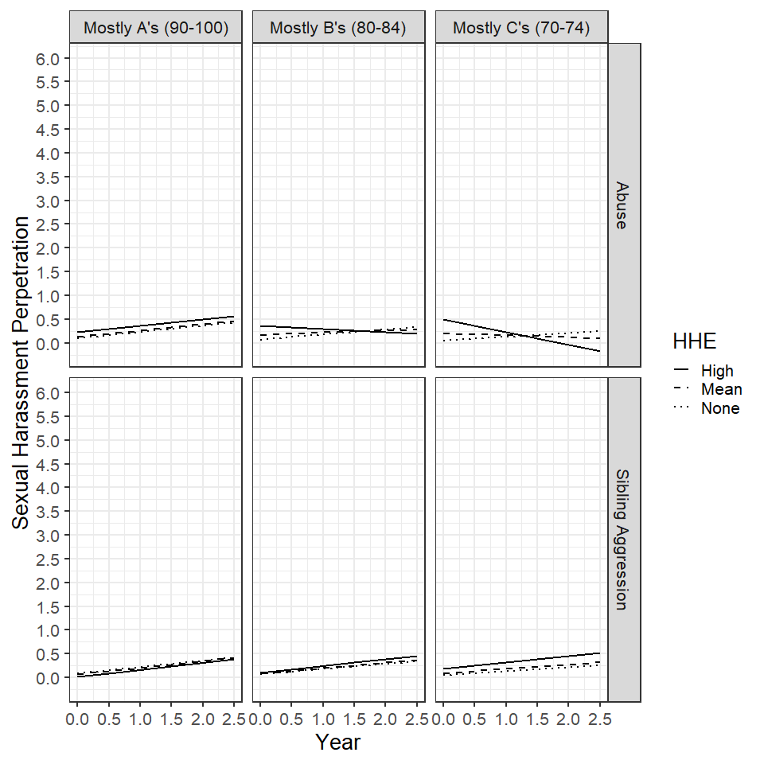

*Note.* HHE = Hostile Home Environment. HHE categories are the mean, mean + 1 standard deviation (High), and scores of 0 (None) on the abuse or sibling aggression scales

*Interaction of Academic Grades and Exposure to Abuse on Hispanic Adolescents’ Sexual Harassment Perpetration*

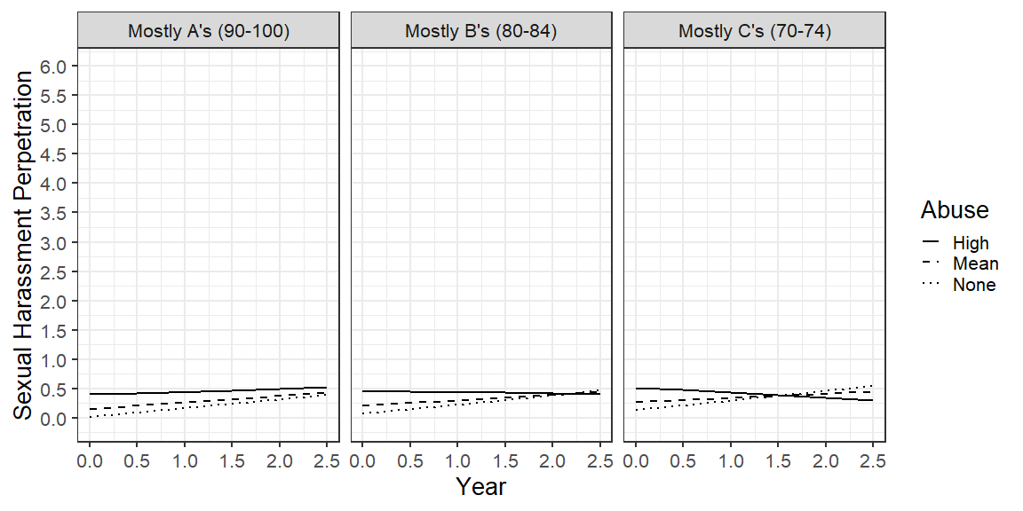

*Note.* Exposure to abuse categories were the mean, mean + 1 standard deviation (High), and scores of 0 (None) on the exposure to abuse scale.

*Interaction of Academic Grades and Early Hostile Home Environment on Black Adolescents’ Sexual Harassment Perpetration*

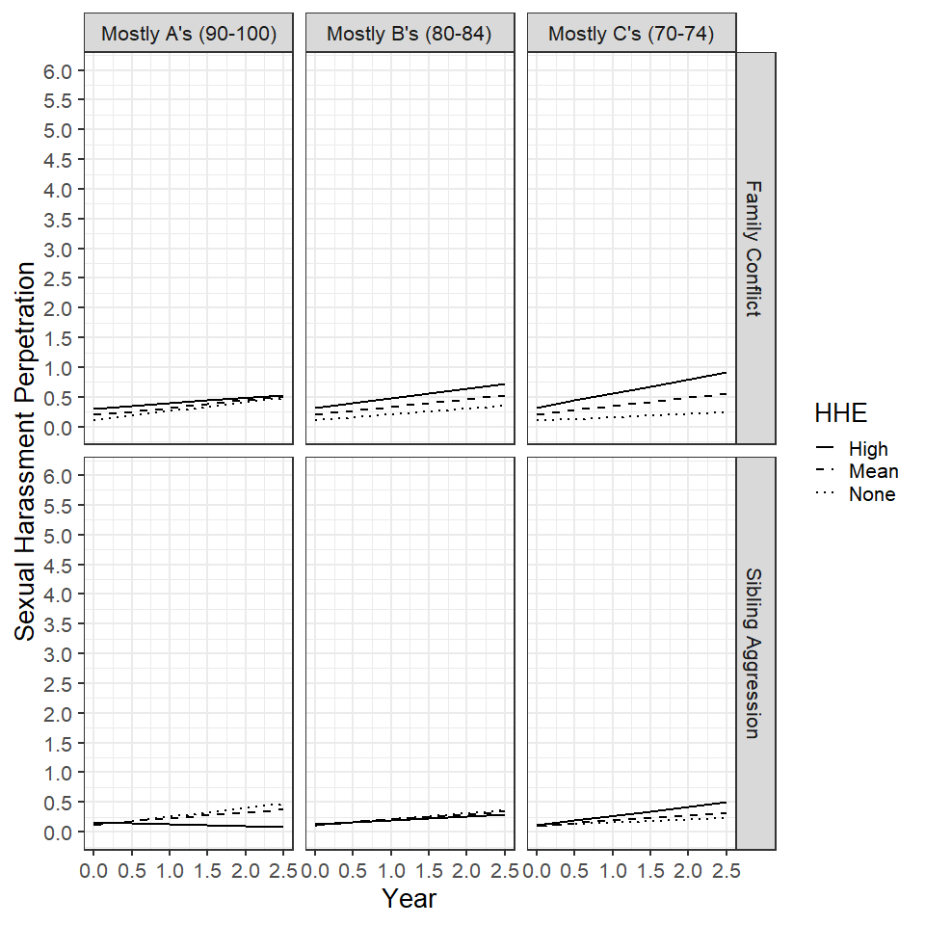

*Note.* HHE = Hostile Home Environment. HHE categories were the mean, mean + 1 standard deviation (High), and scores of 0 (None) on the family conflict or sibling aggression scales.

*Interaction of School Belonging and Early Hostile Home Environment on White (A) and Boy (B) Adolescents’ Sexual Harassment Perpetration*

*Note.* Hostile home environment categories were the mean, mean + 1 standard deviation (High), and scores of 0 (None) on the sibling aggression or exposure to abuse scales.